Calculus 1 Lecture 0.4: Combining and Composition of Functions

C:\Users\Stanley\Documents\Courses\Math\Professor_Leonard\Intermediate_Algebra\ProfessorLeonardIntermediateAlgebraLecture_12_1_Operations and Composition of Functions.doc

Composition
Example
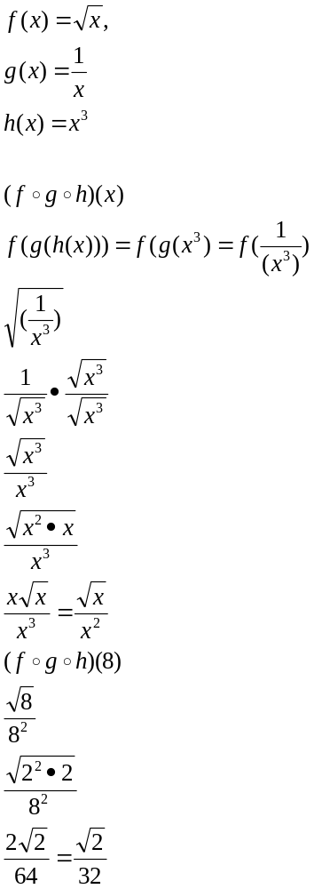
Example
